Mobile Photo Lifecycle Architecture

Group Members
Jim Anderson
Dustin Duran
Trevor Hamilton
Ahror Rahmedov
Vivek Rajkumar
Matt Renzelmann
Operational Concepts

What the System Does
From an end user standpoint the system will operate much as discussed in the Life Cycle Objectives, with several small functional changes. The system consists of three major components: a mobile client, a server and database, and a browser based interface. The system is intended to allow a user to upload pictures taken with a camera phone wirelessly, via the Internet to a central server. Then, via a desktop web browser, the user can manage and organize the uploaded images, and optionally send them to a local photo printing shop.

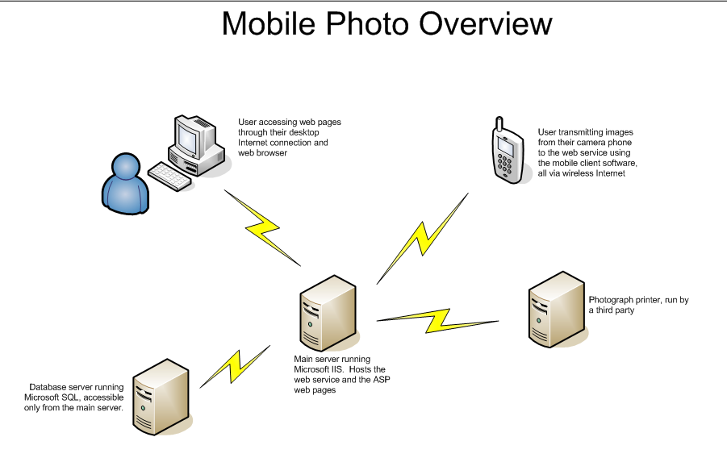

The mobile client will be designed for Nokia Series 60 phones which feature network connectivity, digital cameras, and J2ME MIDP 2.0 support. Future releases could target phones from other manufacturers also conforming to these specifications; however, this is not a requirement at this time. The mobile client allows the user to take pictures, store pictures locally, and send pictures to the server via a network connection. These options will be available to the user through a series of easy to navigate menus.

The database will consist of several tables stored in Microsoft SQL database server. Tables in the database will store information about the users of the system, about the photo shops providing service through Mobile Photo system, and the information about current and previous photo print processes initiated by each user at any time. The initial implementation will have the database server located on UWCSE servers. Depending on demand for performance, later versions can have the database moved to specialized servers to allow more simultaneous connections at the same time.

The web client is the interface that the user uses to access the pictures taken by the mobile client software. The web page will be accessible by any modern browser. The web client is targeted at all parties that consume use this program, as it is where they will be able to actually work with the photos they upload. These actions could include anything – sorting current images, saving images locally, and changing image permissions to allow for public viewing of the image. The user would have to use the web client, since these actions cannot be performed on the mobile device, so the web client is a necessity rather than an option. However, once the user uploads images from the mobile device, a variety of options are available.

User Community
The system is currently targeted at high end camera phone owners. It is through the combined use of the mobile client software and web client that the user may get the most functionality out of the camera. As camera phone quality increases, and their prevalence grows within the market place, Mobile Photo’s target audience will grow to include the average camera phone owner. Furthermore, this product equally suits the needs of both the business professional and the casual picture taker. To cite specific use cases, people on vacation and insurance inspectors would both benefit from Mobile Photo.

Environment
The system is targeted at people with the following hardware and software: 1) Nokia Series 60 phone with an Internet connection via the cellular network, 2) a computer with a web browser and Internet access.

Major Benefits
While wireless Internet access via cellular phones currently remains expensive, the cost will likely decrease as the availability increases. This application may not be widely used upon its introduction, but will develop a user base as camera quality increases and cost of Internet access decreases.
System Requirements
The user would first have to install the mobile client on the phone using a standard procedure. The mobile client software would be packaged as a .JAR file.

The user must establish an account using the web browser client in order to utilize the upload functionality of the mobile software. This account would consist of, among other things, a username and password. The mobile client will then use the username and password during authentication with the server when the user requests to upload a picture.

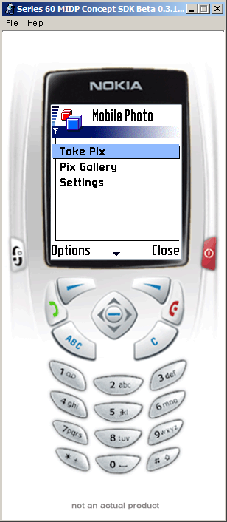
The key focus of the design of the mobile client is simplicity. Due to limitations in the camera architecture, it is necessary for the mobile client to not limit camera functionality, yet still be easy and intuitive to use. Mobile Photo must implement a set of features comparable to the phone’s built-in camera software because images taken with these programs are not available to the other program. The following design will allow the user to easily navigate through the options available:

Upon starting the mobile client on the phone, the user is presented with a list of three options:
1) Take pix
2) Pix gallery
3) Settings
The following sections discuss what happens when the user chooses one of the options listed above.

1) Take pix

The user is presented with a “viewfinder,” a screen that continually updates the view with the display captured by the camera. To take a picture, the user may press the “fire” button or selects “Capture” from the Options menu. Once taken, the captured image is presented on the screen and the user may select from the following options:
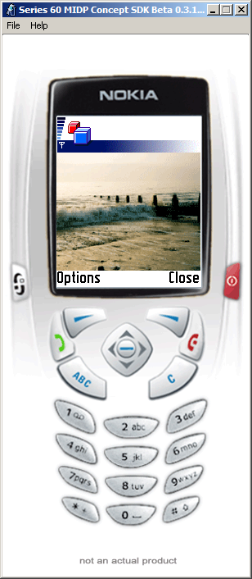
1) Send
2) Save
3) Discard

If option 1 is selected, the user is prompted to enter in a name or accept the default name. The image is then saved to the phone and the user is taken to the main menu. If option 2 is selected, the user is asked to name the image or select the default name, and then the image is uploaded to the server provided the user has network connectivity. After the image is sent, the same image screen is displayed once more. If option 3 is selected, the user is taken back to the main menu.
Technical details:
- Limitations of the phone prevent the client from accessing pictures taken using the built in camera software. Likewise, storing images along with others taken with the built in software is also not possible. Thus, the pictures the client saves on the camera will be separate from those stored on the camera by the built in camera software. This limitation is fundamental to all phones available today.
- For communication with the server, the client will use a system similar to the following: First query the server sending only the username and password. This is just a few bytes and can be completed quickly. The server then responds with an “ok” or “not ok.” This response serves to: indicate if the username and password are valid, and check for network connectivity. If this preliminary test passes, we attempt to send the username, password, picture bytes (in PNG format), length of the picture data, and filename. The server then responds with an “ok” or “not ok.” The client prints an error if the network or server fails at any point in this process.

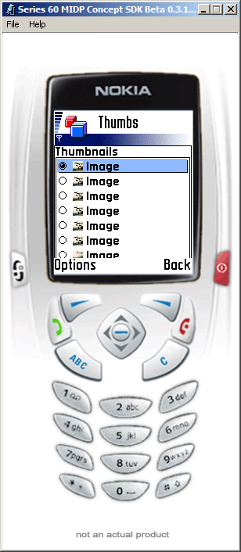
2) Pix Gallery
The client presents a list of all the images stored on the phone. This list does not include those images taken using the built-in camera software—only those images taken by our software. The user selects the image he/she wish to view, and a thumbnail of that image is then displayed. The client displays one thumbnail on the screen at a time.

Once the desired thumbnail is loaded, the user has the option of bringing up a menu with the following options:
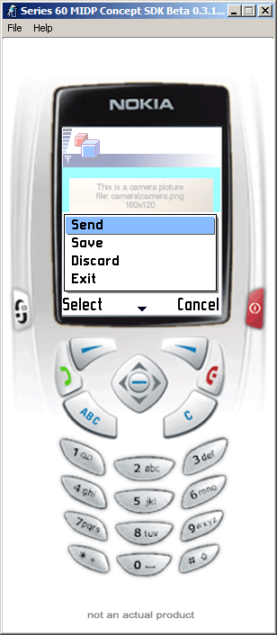
1) Send image to server
2) Delete image
3) Rename image
4) Cancel (Back to list)
Choosing the first option will initiate the same “handshake” discussed in the previous section. The username and password are sent as an initial test, and then the username, password, image data, length, and filename are sent.

The second option removes the image from the camera’s memory. If the user had not already sent the image to the server, it is permanently lost.

If the user chooses the third option, a new window opens with a field for specifying a filename. If the user never specified a name for the file, either after he/she took the picture or in this picture browser, a default name is assigned.

The fourth option simply returns to the list of thumbnails.

3) Settings

The third window allows the user to enter various pieces of information necessary for the operation of the system.
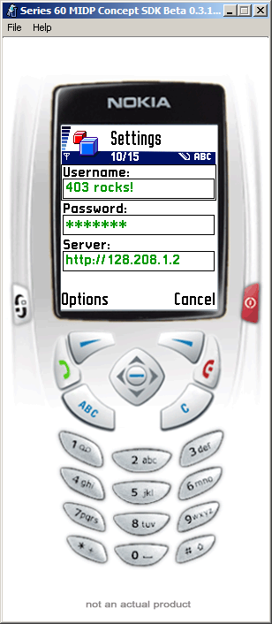
The screen presents the following fields:
1) Username
2) Password
3) Server address
These three pieces of data are stored on the phone for future use. When the user attempts to send a photo to the server, the username, password, and server address stored here are used.
With this system, the user need only enter these details once, when they first setup the mobile client. Thus, the user is relieved of the need to type in this information repeatedly, a time consuming and irritating proposition.

Summary
Below is an image of a state machine that outlines the complete operation of the mobile client as presently envisioned.

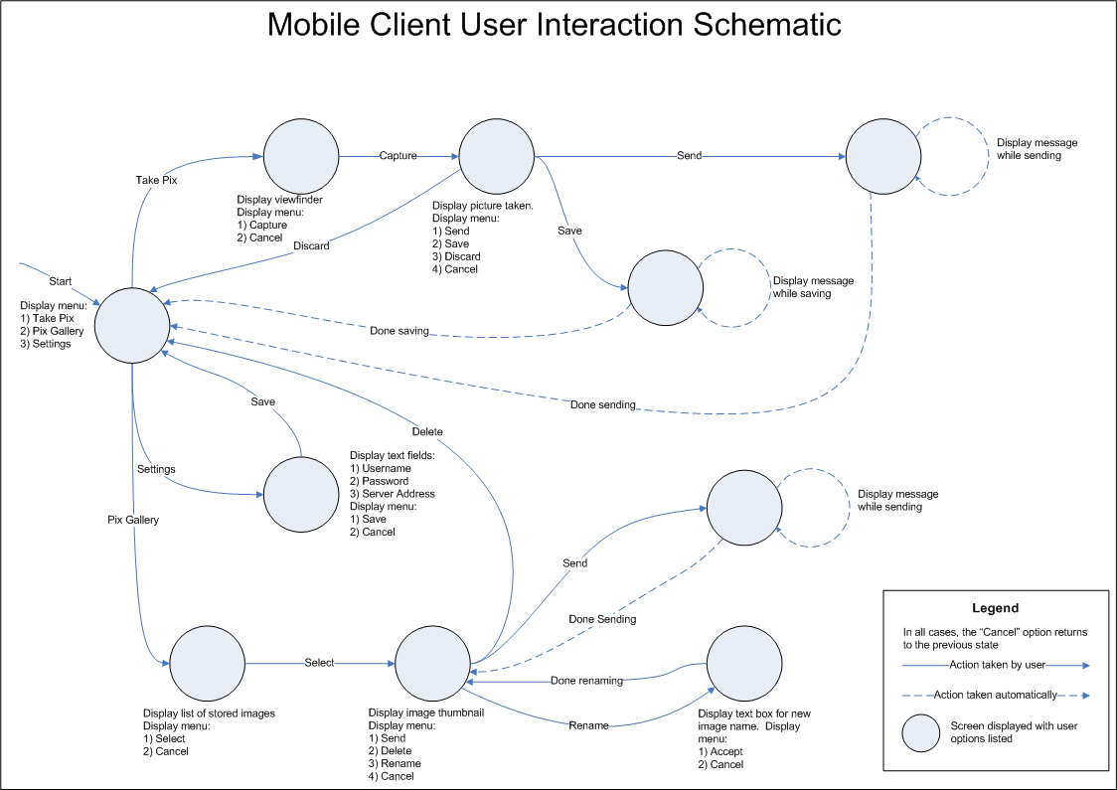

Server and Database
The MobilePhoto database provides a location to store any necessary information. Three main classes of information are stored in the database. The database will be running on a Microsoft SQL Server which allows for easy access to this data from our MobilePhoto Web Services.

To maintain an easy to use and manage environment for users, the database must maintain user information along with all of the information about the users’ pictures. Users’ contact information is stored to allow users to easily purchase prints from online photo shops. Information about users’ pictures is dynamically stored in the database. This allows for easy attribute modifications by users, and easy design expansion for improved functionality. Each photo can have associated with it any number of different attributes, including a user specified file name, comments or description, date, location, occasion, and people in the photo.

To enable users to order prints of their submitted photos, the database maintains information about various photo shops. The database maintains information about how print orders are submitted to each individual Photo Shop when a user places an order with MobilePhoto. Such an order would consist of a record in the PrintProcesses table. Each photo that was ordered will have a corresponding record in PrintProcessPix with the proper UserID, PrintProcessID, and SizeID. The SizeID specifies which type of print a user wanted (3x5, 4x6, 8x10…).

Database Details
The database will have nine tables and has the potential to add more tables if future requirements demand it. All tables will be connected to each other through a number of foreign keys in the tables.

Complete list of fields in tables, and entity relationships are described in the below snapshot of the Mobile Photo database model and the provided database schema.

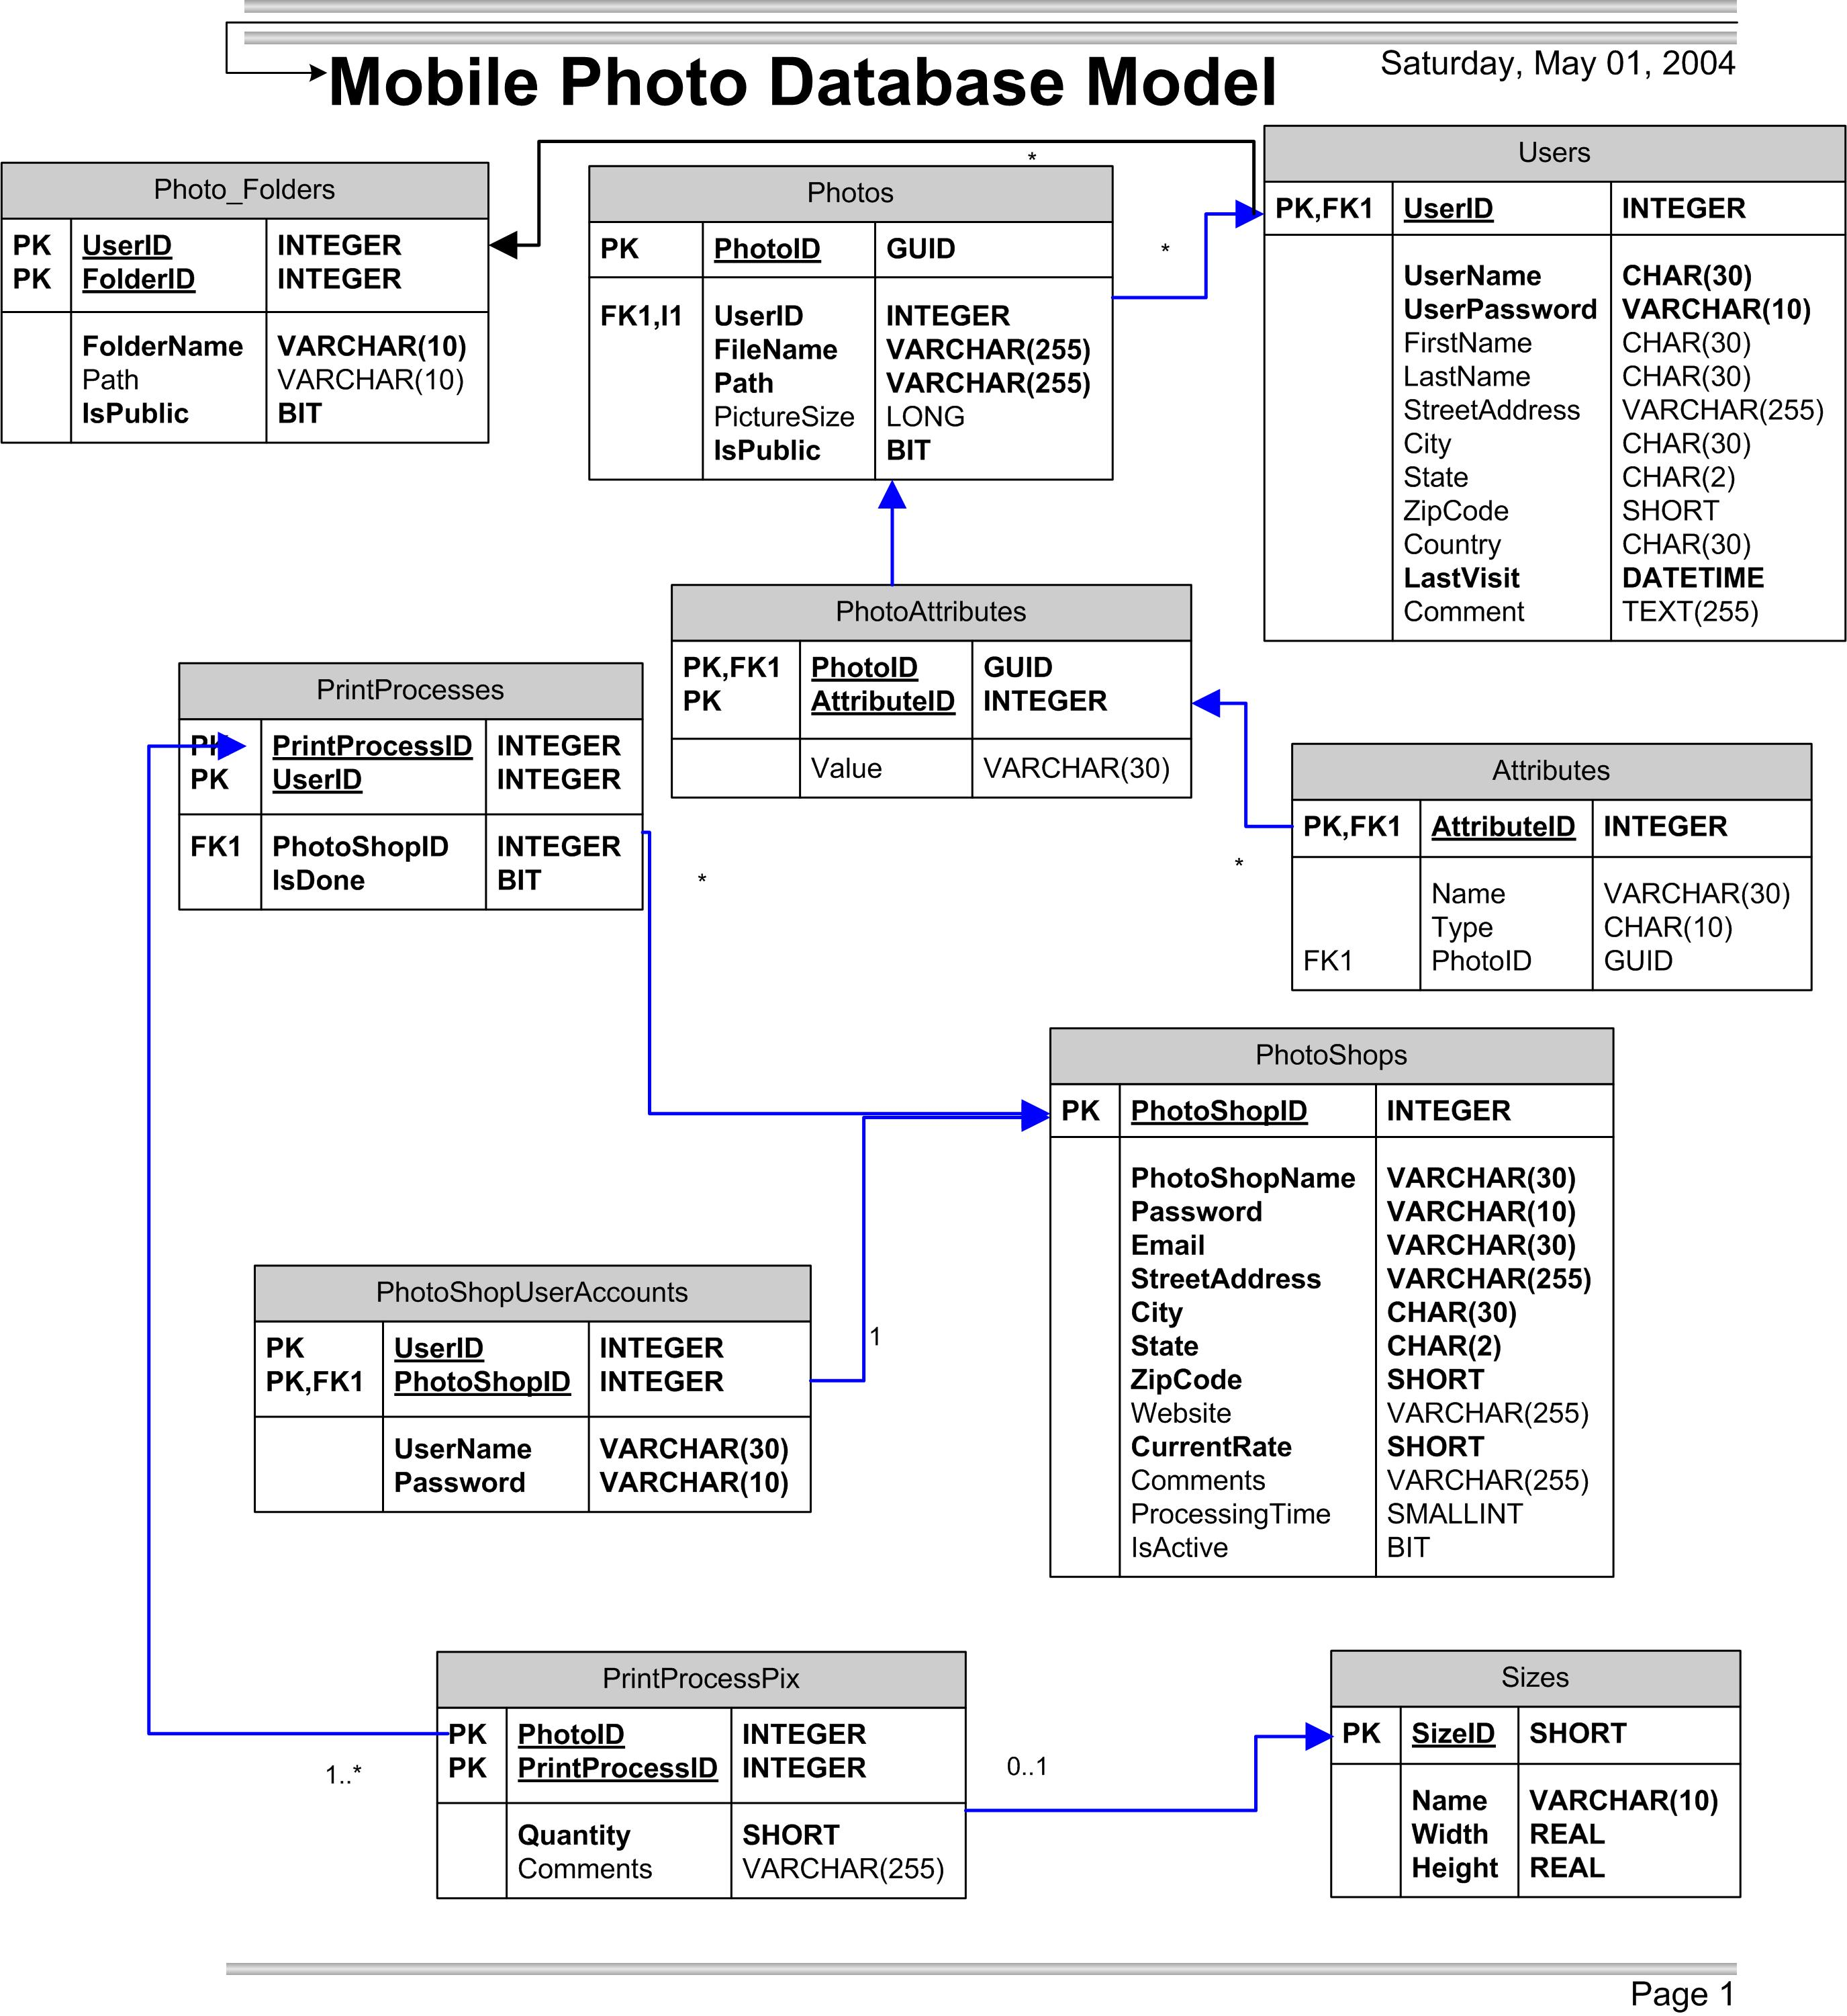

There are four main entities identified for the Mobile Photo database. They are:

- Users
- Photos
- Photo Shops
- Print Processes

They each have their own separate tables in the database along with more supporting tables connected via foreign key relationships.

Global primary keys identify all of the main entities. Those keys are named UserID, PhotoID, PhotoShopID, and PrintProcessID accordingly.

Users table will store information about users, including their user name, first and last name, their password, address, and others. It is connected to the Photos via n-ary relationship. Each user can have zero or more photos associated with their user names and stored in Photos table.

Photos table will store information pertaining to each photo. The system is flexible enough to add more user or server defined photo attributes in the future. This is achieved by allocating a separate PhotoAttributes table to store attribute values. Attributes for a photo are connected via the PhotoID field. The photos table will have fields to indicate the path and file name associated with each PhotoID, and the file size along with others. However it does not contain the picture itself, it will be stored outside of the database on disk. This allows greater scalability.

PrintProcesses table stores information about print jobs ever initiated by users. Each print process can contain one or more photos from the Photos table. PrintProcesses has a field to indicate which photo shop this print process was submitted to. This field is the same as the global PhotoShopID of the PhotoShops table.

PrintProcesses table is connected to the supporting PrintProcessPix table, which stores data about how the user asked each photo to be processed. This information includes the desired print size of the photo, number of copies, and comments by the user. Sizes table is connected to this table making it possible to specify different sizes for pictures.

PhotoShops table will store information about each photo shop that has expressed interest in participating with Mobile Photo services. This information includes the photo shop name, address, password, average processing time for a print process, and whether it is currently an active member.

Browser Based Interface
We plan to implement these core features for the web client:
- a registration page where the user will be able to:
  - create their own user account
  - specify personal information
  - configure their own preferences
- a login page where the user will enter in their own username and password
- *a dynamically created page for each user that will allow interactions specific to that user’s needs (once the user has logged in)
- ability to set certain photo/image attributes such as:
  - name
  - visibility (image permissions)
  - folder location of image
- ability to set certain image folder attributes such as:
  - name
  - visibility (e.g. folder is available publicly vs. private usage)
- ability to send particular images or sets of images to be printed at some print shop
  - for the scope of this project, only one print shop will be supported initially
- publicly viewable pages indexed by username (given that the particular username has publicly viewable images/folders)
- options to change personal information and preferences
- a help (or FAQ) link

* The dynamically created page will have a specific layout. There will be these core options on every such page:
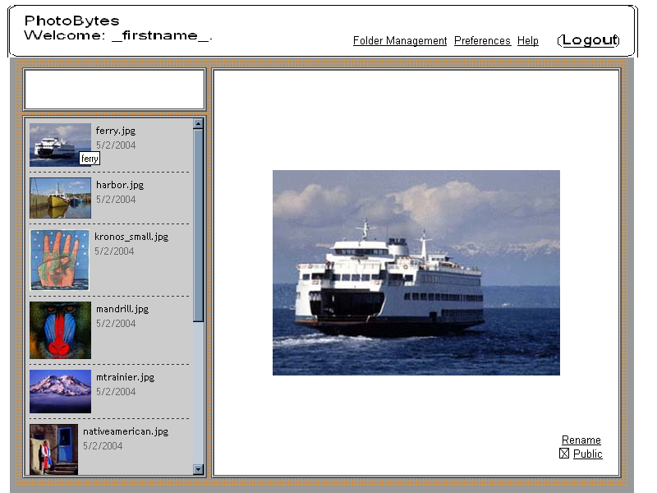
- one sidebar frame that will let the user:
  - change folder (from a list of existing folders in the form of a drop-down menu)
  - view thumbnails of all the images in the current folder
    - (each thumbnail would be clickable so that the image would be displayed full-size on the second frame)
- one main frame that would:
  - display the currently selected image full-size
  - present the user with a list of options specific to that image such as:
    - allowing the user to change the name of the image
    - allowing the user to change the visibility of the image
    - allowing the user to change the location (folder) of the image
    - (optional) allowing the user to save the image locally on their own machine

There will also be a link to a page where the users can Configure Folders with these options:
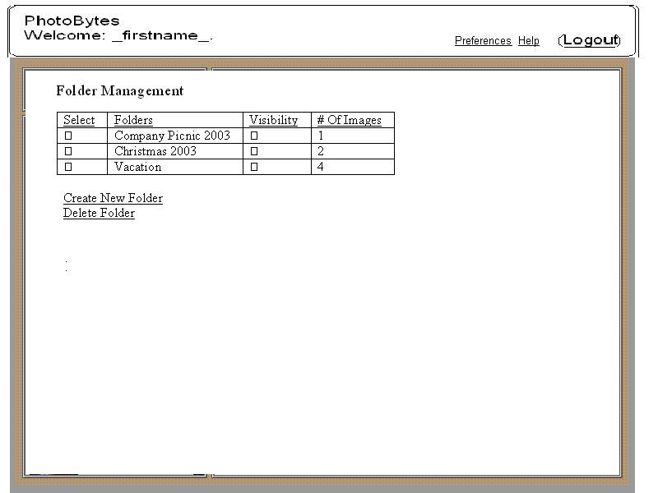
- the ability to create a new folder
- the ability to modify a particular folder’s visibility
- the ability to rename a particular folder (as long as that folder does not already exist)
- the ability to move all images from one folder into another
- the ability to click on any folder name and have the folder be loaded up into the image-browsing page

On this Configure Folders page, information will also be displayed (in some table format) specific to all the existing folders such as:
- name of that folder
- number of images in that folder
- current visibility of that folder

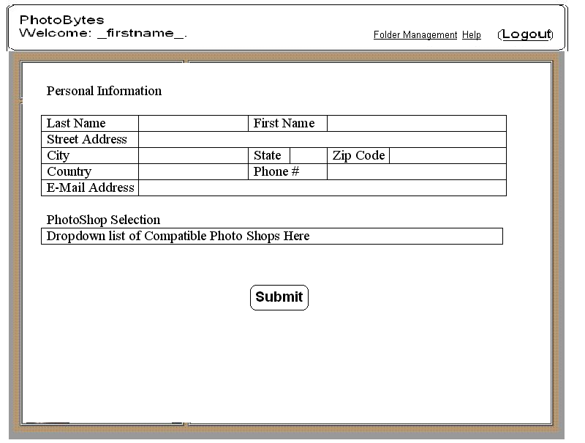
There will also be a link to a page where the users can Update Personal Information with these options:
- ability to change password
- ability to change user-specific parameters such as:
  - personal name, address, contact information (phone number, email address), location of print shop

The very front login page would let:
- registered users login using their username and password where:
  - a cookie would be created to track what user is currently logged in (and a session variable would initiated)
- new users to register
- registered or unregistered users browse publicly viewable photos (sorted by user)
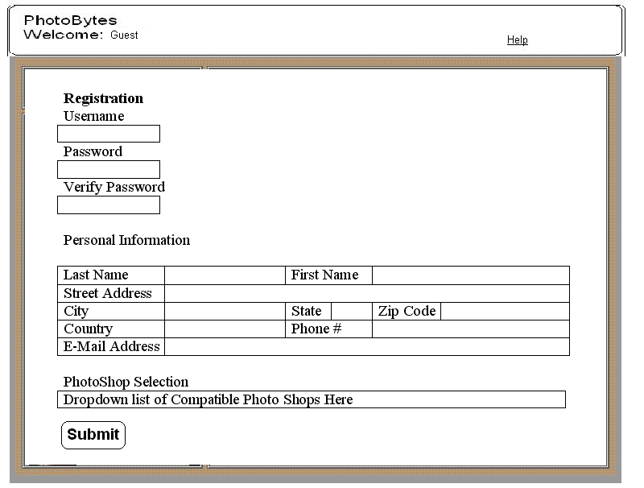
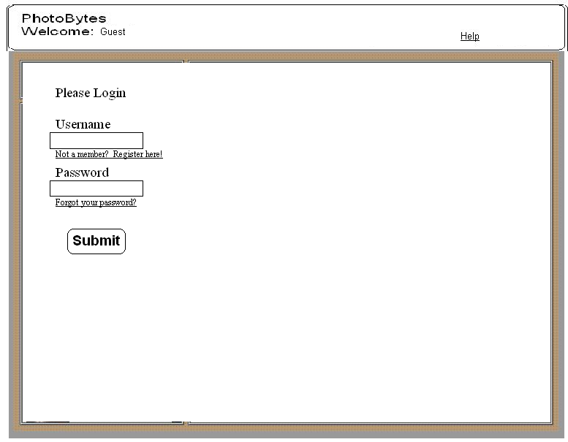
The sitemap as it stands right now:

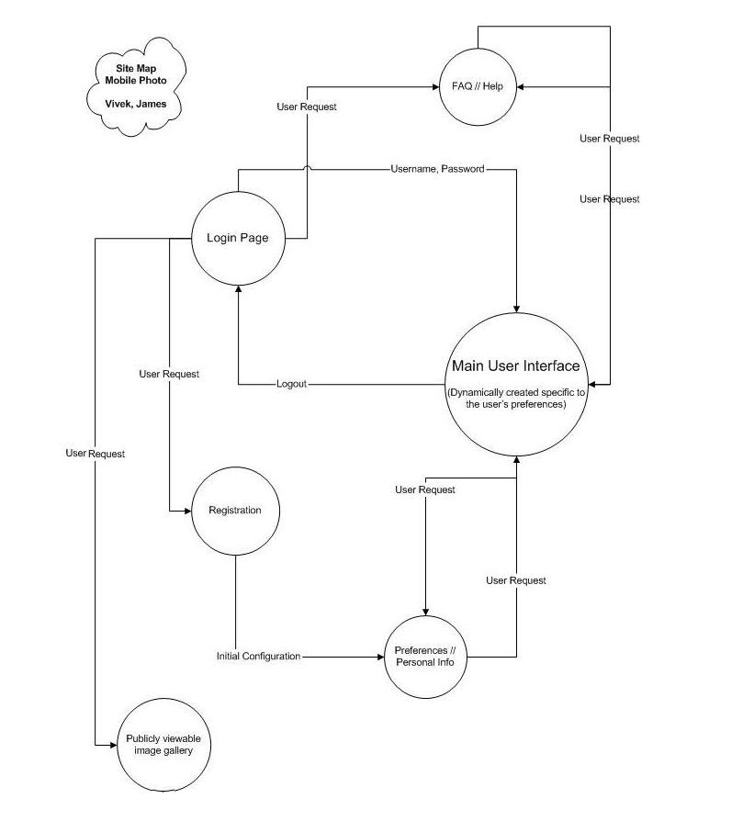

Architecture

Mobile Client
The mobile client software, written using the Java J2ME with MIDP 2.0, consists of a set of Java source code files. These files, when compiled, pre-verified, and packaged into a .JAR, form the mobile client portion of the system.

The mobile client itself is being developed using Sun ONE Studio, a free IDE distributed by Sun, which supports the use of emulators. Due to budget restrictions, no Nokia Series 60 phone is available for testing purposes, making the presence of an emulator all the more important.

Below is an image outlining the relationship between the various Java classes that will make up the mobile client. The classes in yellow at the top of the diagram represent built in Java class definitions. The classes in the middle of the diagram represent individual instances of classes we plan to create. The classes in yellow at the bottom of the diagram represent instances of built in Java classes. The Legend explains the meaning of the arrows.

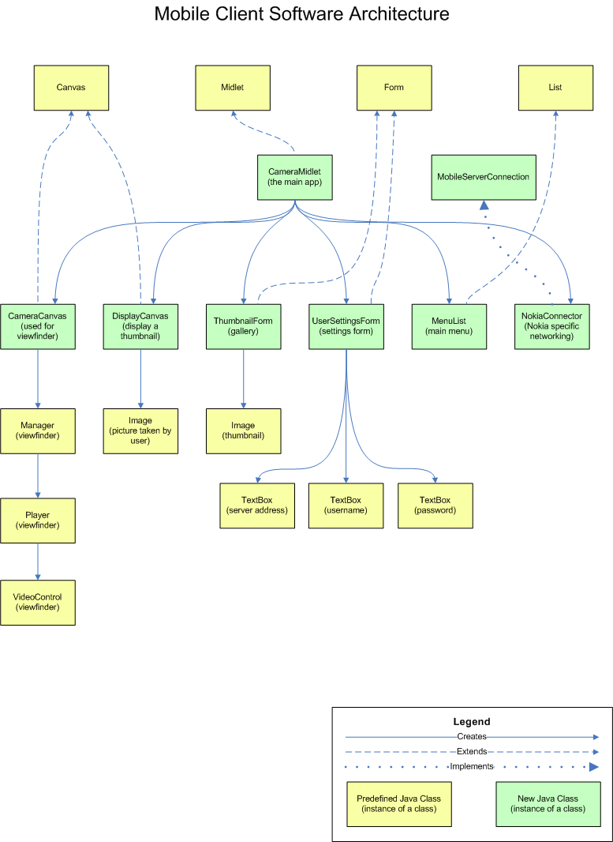

The key to an effective mobile client design is portability to different phones. The initial product, which will be released June 2, will be targeted at the Nokia series 60 of phones. However, we anticipate the eventual need for wider phone support, and thus our design includes several important features such as “information hiding.” In particular, we plan to create a software interface for handling network connections. Since networking varies from phone to phone, and protocols such as Bluetooth and 802.11b are handled differently, we feel that creating an abstract interface for network communication is key to portability across different mobile platforms.

The act of taking a picture and retrieving the picture data is, in contrast to networking, better standardized, and thus no separate interface should be necessary. One possible issue is image formats. Other phones may use formats other than PNG, but for simplicity we offload the responsibility of dealing with different image formats to the server.

Database
Database will be hosted on a Microsoft SQL server on University of Washington servers provided by the CS department. Main application server will be able to talk to the database via asp.net scripts, which encapsulate SQL queries. The changes to the database will also be carried out in this manner. These changes can include adding new users, photos, photo shops, and print processes to the database.

The system will make use of the built in ASP functions to query SQL database and leverage the compatibility of Microsoft SQL, ASP.NET, and .NET development environment to achieve a robust performance of the database.

Web Service
The MobilePhoto web service provides an interface between users and the back end database. Through the use of this web service, the web client can obtain information about the requesting user. This web service is utilized by the mobile client to upload new pictures. Username and password combinations can also be verified using this web service, thus preventing the situation where a user pays for bandwidth to upload a picture only to realize that he/she typed their password wrong.

The web service must provide the following functionality:

- Provide a list of folders for a given userID
  - FolderList getFolders (String username, String password);
- Provide a list of pictures for a given userID and folder
  - PictureList getPictures (String username, String password, int folderID);
- Allow users to add photoshop accounts (for online photo ordering)
  - Boolean createPhotoShopAccount (String username, int PhotoShopID, String username, String password);
- Accept and process online photo orders given a userID and photoshopID
  - Boolean orderOnlinePrints (String username, String password, int PhotoShopID, int[] photoIDs);
- Access the list of available PhotoShops
  - PhotoShopList getPhotoShops (int zipcode);
- Accept and store new user submitted pictures
  - Boolean submitPicture(String username, String password, int type, String name, Byte[] picture);
- Verify Username and password combinations
  - Boolean checkCredentials (String username, String password);
- Add additional users
  - Boolean createNewUser(String username, String password, String firstname, String lastname, String address, String zipcode, String country, String e-mail);

Browser Based Interface
The website will be hosted on the same machine that provides the web-service to the mobile client. It will talk to the database via ASP.net functions, as well as generate the specific web clients for users using ASP.net functions as well. Using Microsoft’s ASP.net architecture to implement the website should allow for seamless integration of all the components.

Lifecycle Plan

Schedule Proposal for Mobile Photo

Mobile Client Group — Matthew Renzelmann and Dustin Duran
This group will focus exclusively on mobile client development, the software running on the camera phone. Due to the relatively small amount of coding necessary, and the comparative progress made already, we anticipate at least one group member (either Matt or Dustin) being able to supply additional assistance to the other portions of the project.

May 1 [Done] – Complete a prototype of the mobile client. Functionality should focus on implementing a user interface consistent with the specifications outlined in this document. Necessary features include the ability to take pictures, the ability to save pictures, and the ability to access the individual bytes of the picture data in PNG format in anticipation of sending the data to the server.

May 14 [In progress] – Complete a beta version of the camera client, with, in addition to the above functionality, the ability to send pictures to the server, and the ability to view, send, rename, and delete previously saved pictures.

May 26 – Complete a working version of the entire mobile client. Additional functionality includes “friendly” error messages if failures occur. Specific areas of focus for error handling include: storage space limitations, network unavailability / disconnects, camera not present, catching and handling elegantly all exceptions raised.

Jun 2 – Complete any remaining testing and ship the final version.

Web Client Group – James Anderson and Vivek Rajkumar
This group will be primarily responsible for writing the ASP.net functionality for the webpage that acts as the interface between the user and their images on the server. This will be a substantial part of the project, and assistance will be needed from the other two groups as they complete their portions of the project.

May 1 [Done] – Specify the capabilities of the website.

May 14 [In progress] – Implement at least a basic interface so that we can test the other aspects of the project. User authentication and folder management need not be implemented yet. With luck, have the web-pages implemented, just not all the functionality active.

May 26 – All functions should be active. Debugging should be occurring with all aspects of project. Project will be evaluated at this point for “gold plating” that can be snipped off.

June 2 – Project should go gold and ship to all interested parties.

Database and Server Group — Trevor Hamilton and Ahror Rahmedov
May 1 [Done] – Specify web service interfaces and database architecture

May 7 [In progress] – Implement basic but functional database (tables, relationships, triggers, and queries), Implement checkCredentials Web Service.

May 14 – Fully implement database and have basic functionality of all web services.

May 21 – Fully implement web services. Start solidifying online print ordering procedure (what happens when the database/web service receives online order request).

May 25 – Online ordering system functioning for at least one online PhotoShop.

Feasibility Rationale

As it stands now, the mobile aspect is very possible. Code has been tested and implementing supporting the features that we feel necessary to implement the project.

The SQL and back end server are now designed, and will be implemented in the near future. Work has begun on implementing the basic functionality of the web services. These are straight forward as they will be responsible for obtaining and processing information from the database.

The web client has been designed and specified. Implementing this will require learning a new language, but there are many tutorials and other reference materials available on the web that describes how to implement the functionality that is required for this project.

When considering all these factors, and the effective division of our resources, we feel this project is quite feasible given the timeline at hand and result in the shipping of a complete and usable product by the deadline set.

